Competitive Pokémon Support Vector Classifier

CSIT 598-01 Machine Learning

Dr. Peng

5/16/19

CJ Conti

The Pokémon video game series is incredibly popular, with the entire series having sold 300 million games (1). In addition, it has a thriving competitive battling community, with a variety of events, from local tournaments to national championships. A website named Smogon classifies Pokémon into various tiers based on how competitively viable they are. This project explores Smogon’s tier list for single battles with six Pokémon in particular. Analyzing this dataset of Pokémon and the tiers they are placed in should show what makes certain Pokémon better than others for competitive battling.

The Smogon tiers for competitive Pokémon battling include

|  |  |  |
| --- | --- | --- |
| Ubers Tier 0 | Overused(OU) Tier 1 | Under Used(UU) Tier 2 |
| The strongest Pokémon. They are usually banned from competitions. | The most competitively  viable Pokémon outside of Ubers. | Pokémon that are competitively viable, but slightly less so than ones in OU. |
| Rarely Used(RU) Tier 3 | Never Used(NU) Tier 4 | PU Tier 5 |
| Pokémon that are  rarely used in  competitive battling. | Pokémon that are  practically never used  in competitive battling | The least competitively  viable Pokémon. |

In order to determine how much of an effect certain attributes have on the tier a Pokémon is placed in, a Support Vector Classifier(SVC) was used to create predicted classifications for tiers based on the attributes of Pokémon in those tiers. The attributes were determined by getting values from six main stats, Hit Points(HP), Attack, Defense, Special Attack, Special Defense and Speed. The attributes used as X values are:

|  |  |  |  |  |  |  |  |  |
| --- | --- | --- | --- | --- | --- | --- | --- | --- |
| Total | Lowest Stat | HP | Highest Attack | Highest Defense | Lowest Defense | Speed | Stat Standard Deviation | Max Stat-Min Stat |

In order to determine how certain attributes effect how useful a Pokémon is, two attributes are standardized and then used as the X values and the tier is changed into a corresponding number from 0 to 5 and used as the Y value. Four support vector machines(SVM), an svc with linear kernel, a linear svc, an svc with radial basis function(rbf) kernel and an svc with polynomial (degree 3) kernel, are used to classify the Pokémon. Pokémon in two different tiers are compared to one another and each combination of attributes is used to classify the selected Pokémon into two different classes in order to find what two attributes lead to the most accurate predictions. If the accuracy for two attributes is high, that means that combination of factors has a large effect on the tier a Pokémon is placed in. On the other hand, if the accuracy for two attributes is low, that means that combination of factors has a small effect on the tier a Pokémon is placed in. This observation method allows for all combinations of attributes and tiers to be tried and for the hypothesis to be properly tested.

The main hypothesis upon beginning this project was that predictions would be very accurate due to Pokémon in different tiers having highly separated stats, even if they were one tier away from each other and that the accuracy of comparing two tiers would increase as the distance between tiers was increased. In addition, Ubers would have the most accurate results when compared to other tiers due to the power of Pokémon in Ubers. OU was compared with NU and compared with UU to see if increasing the distance between tiers increased the accuracy. Ubers was compared with UU and compared with OU to see if Ubers had the most accurate classifications versus other tiers and if increasing the distance between tiers increased the accuracy.

For each comparison between two tiers, only the most accurate classification is shown in order to compare the classification results for each combination of tiers.

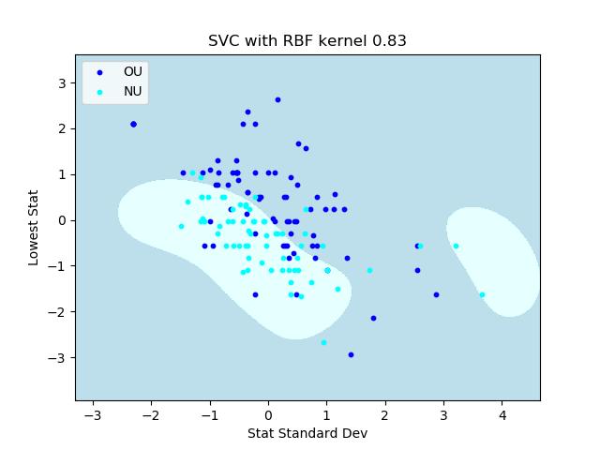

Figure 1: Classifying OU(Highly Popular) vs NU(Extremely Unpopular)

The results of comparing different tiers matched some but not all parts of the hypothesis. When comparing OU vs NU, most of the Pokémon in OU have higher stats than those in NU, but there is still an overlap between the two tiers, with the accuracy being imperfect. Even when comparing the most competitively viable Pokémon and some of the least competitively viable Pokémon, many of the Pokémon in OU are near the space for the NU class. The classification displays the small difference between stats for the two tiers.

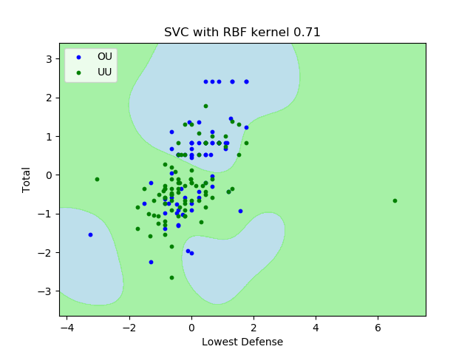

Figure 2: Classifying OU(Highly Popular) vs UU(Somewhat Popular)

When comparing OU vs UU, the classification accuracy drops immensely as predicted, since UU is closer to OU than NU is. There is a great deal of overlap between the two tiers. Before conducting this experiment, much more accurate results similar to those of the iris data were predicted. However, this dataset is more complicated and the classification results show that only subtle differences separate Pokémon into different tiers.

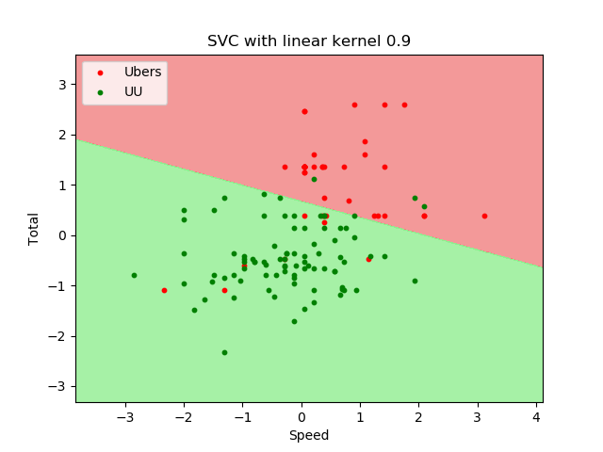

Figure 3: Classifying Ubers(Too overpowered for tournaments) vs UU(Somewhat Popular)

However, stats still do make a difference as shown comparing Ubers with other tiers. The classifier is able to more accurately identify Pokémon in Ubers vs UU than Pokémon in OU vs NU. This justifies why the Pokémon in Ubers are banned, they are noticeably better than Pokémon that can be used somewhat competitively. Very few of the Pokémon in Ubers fall inside of the space for the UU class and the space for the Ubers class is where the total of stats and speed are both significantly greater than average.

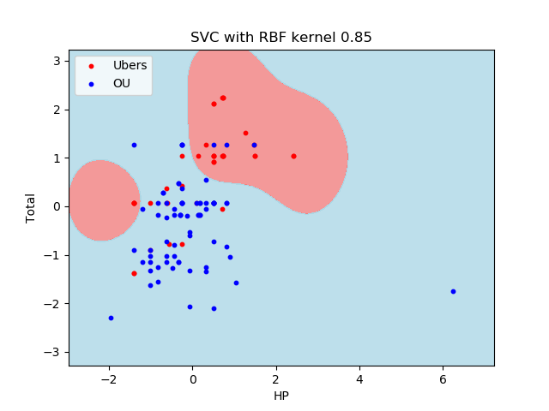

Figure 4: Classifying Ubers(Too overpowered for tournaments) vs OU(Extremely Popular)

Even when classifying Ubers vs OU, the tier closest to Ubers, the accuracy is far higher than classifying OU with its closet tier UU. In fact, the most accurate classification for Ubers vs OU is more accurate than the most accurate classification for OU vs NU, where the two tiers are far more separated. As predicted, the Pokémon in Ubers are most easily identified out of all of the tiers due to their far higher stats than most other Pokémon.

Attempting to classify Pokémon by using an SVC shows that the Pokémon video game is well balanced since the most competitively useful Pokémon do not have far greater stats than the least competitively useful Pokémon. While the strength of Pokémon in Ubers seems to contradict this statement, most of the Pokémon in Ubers are designed to be overpowered and are banned from being used in tournaments. Pokémon in Ubers have deity like abilities, such as power over time, space or the weather, which justifies their strength and improves the games by making them fun. The Pokémon that can be used in tournaments actually have quite similar stats. If the Pokémon video game series were simply about which Pokémon has bigger stats, it would be quite a boring game. Instead, stats play a minor part in determining how useful a Pokémon is, which is shown by how relatively inaccurate the classifications for OU vs UU are, and allows the game to be more strategic. Other factors influence a Pokémon’s competitive viability, such as its abilities, its collection of moves, and its type coverage, which are much more difficult to convert into numbers for a classifier to use and thus were not used here.

Overall, the difference between the most competitively popular Pokémon and somewhat competitively popular Pokémon is quite small, which is shown by the SVCs imperfect classification rate. Pokémon in Ubers have substantially better stats than other Pokémon, which is part of why they are in that tier and is displayed by the high accuracy for classifications involving Pokémon in Ubers. While stats do play a role in how useful a Pokémon is competitively, they are not the only factor that determines the competitive strength of a specific Pokémon.

Works Cited

(1) Minotti, Mike. “Pokémon Passes 300 Million Games Sold as It Eyes Super Mario.” *VentureBeat*, VentureBeat, 27 Nov. 2017, venturebeat.com/2017/11/27/pokemon-passes-300-million-games-sold-as-it-eyes-super-mario/.